Sudo apt install make

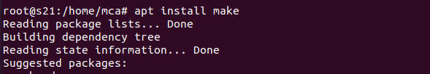

Sudo apt update

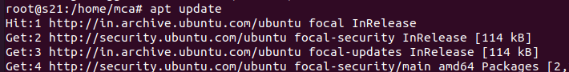

Make –version

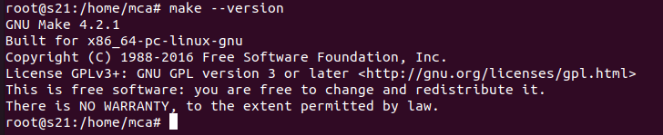

Changing to make dir

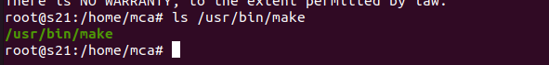

If error occurs

**Sudo apt install build-essential**

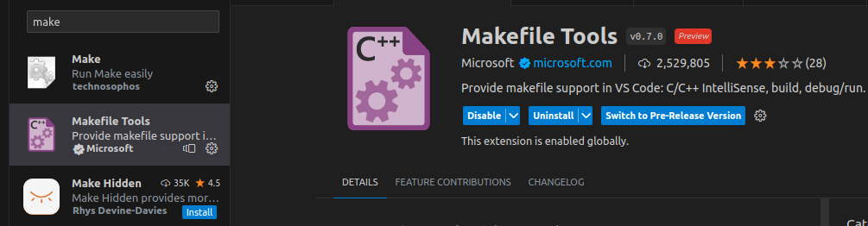

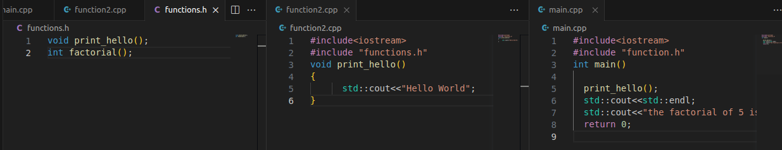

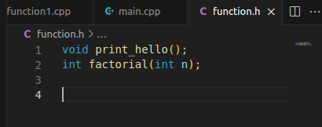

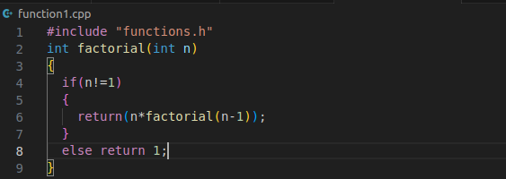

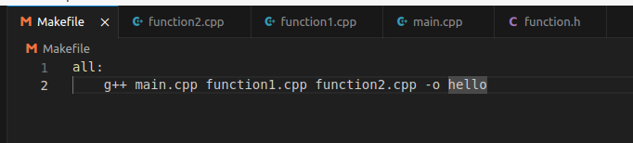

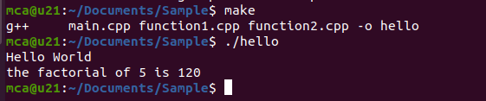

**Cmake**

